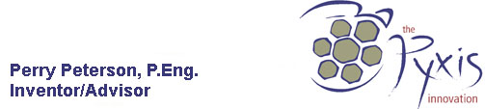

PyxNet

Submitted by:

the PYXIS innovation inc.
Suite 201, 645 Gardiners Road
Kingston, ON
K7M 8K2
T: 613.389.6619
F: 613.389.2341

(Eugene Girard, Vice-President, Research)
egirard@pyxisinnovation.com

Submitted May 31st, 2006

In Response to:

Industrial Research Assistance Program

Funding Requested: $95,998.98

Delivered to:
National Research Council Canada
ITA: Don Snedden, P.Eng., M.Sc.

PROJECT PROPOSAL

- Project Title: PyxNet

- Executive Summary
2.1 Abstract

The PYXIS innovation is please to present this proposal to the National Research Council’s Industrial Research Assistance Program.

The goal of this project is to implement the PyxNet geo-data distribution channel. PyxNet extends the operation of the PYXIS Digital Earth Reference System to include an entire network of collaborating nodes, by leveraging the bandwidth, storage, and processing capabilities of the entire network. All geo-data, resources, and processes within the network are protected through a distributed license management mechanism which enables their commercialization while maintaining security and privacy.

2.2 Business reasons for undertaking this project
2.2.1 Core Business/Technology

Nature of Business

Legal Name: the PYXIS innovation inc.
Legal Status: Corporation
Date of Incorporation: July 23rd, 2003
Ownership: 100% Canadian
Controlling interest: Perry Peterson, President (84%)
Other Owners: Craig Dore (16%)
Business Registration Number: 88272 8801

the PYXIS innovation inc. is a software development company. At the PYXIS innovation we have developed a Digital Earth Reference Model that allows all users to find, view, integrate, and share, spatial data on-demand. We sell a platform for on-demand geospatial data discovery, integration and analysis to an international market. The platform is built on our Digital Earth Reference Model – a fixed Earth grid, indexing and algebra. Digital Earth is a new emerging medium that enables geo-located data to be ubiquitous and useful.

Our current products include the PYXIS Digital Earth Reference Model (PYXIS) sold through OEM Licensing or Customization Contracts, the Software Development Kit (SDK) that allows solution providers to build applications on the DERM, and the PYXIS Tactical Visualization Tool that allows the user to visually interact with spatial data.

Main Customers and Competition

The emerging value network of Digital Earth will contain several key driving components:
- Those who seek knowledge to make evidence based decisions through multi-source Earth observations - Edge Users.
- Those who wish to capture, record and present raw observations – Earth Observers.
- Those who facilitate the homogenous semantics of disparate observations for Edge Users - Single Source Publishers.
- Those who create value added applications or data products on single source or multi source observations - Platform Partners.
FOCUS: virtually any industry can benefit from our technology. We have focused on securing high level adoption in two key industrial sectors: Defense and Conservation.

The Military has provided us with rigorous user requirements that have allowed us to build high quality software. The Conservation Community is global, disparate, low-tech (in terms of bandwidth and access to current hardware), and vast. This is the perfect community to prototype in an End User environment. The IUCN-World Conservation Union, the largest conservation organization in the world has endorsed PYXIS as the solution for sharing spatial data. http://www.iucn.org/en/news/archive/2006/03/28_digital_earth.htm Learning to meeting theeir requirements with robust capability will be a challenge.

USER ADOPTION: an emerging market requires patience. Many end users see GIS and SIM as established solutions – safe solutions. We have developed our software with this in mind. For example, we are data and application independent so large organizations do not have to abandon GIS solution or legacy data to take advantage of the value found in PYXIS. Nevertheless, we have found the greatest success with NEW users of spatial data – those for whom existing technology was previously a barrier to entry.

STRATEGIC DEVELOPMENT: it is critical that all members of our community emerge simultaneously. End users who require spatial data must have sources available. Data publishers require a demand for their data. Application developers must have an attractive business model to invest in.

We have invested considerable effort to ensure the timing of our launch is ideal. We have established partnerships with data providers and end users who support our model for strategic development and who champion our cause. Execution is as important to them so it is in this collaborative spirit that we meet this challenge.

There are currently no Digital Earth Reference Systems publicly available and, therefore, no direct product competition. Barriers to market entry include existing business processes, rate of technology adoption, and international applicability. However, we feel that the value of our technological innovation and the opportunity for new product and market development will be a compelling reason for Satellite Image Providers to seriously consider our product as a viable option.

Strategy

the PYXIS innovation has begun an aggressive 24 month growth strategy. Fueling this growth is the demand from current and new clients to strengthen our product offering. Continued product sales will continue to fund most development activity. However, as we transition from military to commercial products, we will require new and additional leverage for R&D activities beyond DRDC and SR&ED tax credits. We will build a firm relationship with IRAP to gain interest in continual support for our commercial R&D activities.

We are seeking $5M in equity capital dedicated to increasing our Marketing and Sales support to 15 full time staff and ancillary requirements: financial, contractual and legal. (We are currently negotiating terms for this financing.) We are building a board of directors and a formalized board of advisors. We have hired a professional lobbying organization to help us structure business relationships with governments and large defense contractors. We are recruiting a CFO. We have moved to larger accommodations to prepare for the increased staff. We continue to build our relationships with domestic and international research community – we will continue our annual academic grant program.

A key component of our success is to engage single source data and application partners. To do this significant effort will need to be put toward building these relationships. As a real example of our efforts, in the past 4 months we have increased our domestic and international travel to support new clients and strategic partnerships PYXIS has met with hundreds of potential users and partners in London, Cambridge, Surrey, Geneva, Gland, Vancouver, Edmonton, Denver, Montreal, Canberra, Cape Town, Washington, and Curitiba (Brazil) with significant success.

Technical Capability

We have internal and external Research and Development capability. Since our inception in June 2003, we have successfully completed over $3M in direct Research and Development primarily under the scientific advisory of Defence Research and Development Canada. Over the past three years we have revenues of $ 2.4 Million.

We have completed the following previous R&D Contracts:

- PYXIS PIPE [DIR 563, Contact: Dr. Paris Vachon, DRDC Ottawa]
- Digital Earth Reference Model [DIR 497, Contact: Francois Letourneau, DRDC Valcartier]
- PYXIS Visualization [Contact: Cpt. Nicholas Pedneault, PMO ISTAR]
- PYXIS TVT [Contact: Francois Letourneau, DRDC Valcartier]
- PYXIS for Feature Data [Contact : Tom Hammond, IUCN]

We currently employ technical staff (12 employees, 4 contractors); 4 PhD researchers, 3 M.Sc. Computer Scientists, 4 Engineers, and 5 B.Sc./Dipl. Tech. Software Developers with the PYXIS R&D teams. We keep a dedicated research office at the Canadian Centre for Remote Sensing in Ottawa with links into DRDC Shirley’s Bay and Valcartier.

We maintain directed research contracts with external academic as required for specific areas of investigation: mathematics, geomatics, cyberspace, remote sensing application and image algebra. Currently, these include Dr. Gerhard Ritter and Dr. Andrew Vince at the University of Florida, Dr. Arturo Sanchez, University of Alberta and Dr. Charles Herring Queensland Australia. We also maintain informal relationships with external firms with R&D capacity: MDA, C-Core, Thales, CAE, CMC, Intermap and General Dynamics Canada.

For further information, please contact:
Business: Perry Peterson, P.Eng., President (ppeterson@pyxisinnovation.com)
Technical: Eugene Girard, VP Research (egirard@pyxisinnovation.com)
Financial: Colleen Johnson, VP Operations (cjohnson@pyxisinnovation.com)

2.3 Financial Position Indicators: Fiscal Year End (June):

Financial History:

PYXIS has been built on an original founder investment of $250,000. Through the past three years, we have successfully leveraged this amount to complete $3 Million in Research and Development. Outside investment to accelerate development has been offered [$1.5 Million from BDC Technology Seed Investment group in November 2004] but rejected based on terms. As we are now moving toward a full product offering in November, we are, again, investigating Venture Capital. Recently, we presented at the Canadian Venture Forum and gained significant attention as a finalist in the 2006 Victor Award. Subsequent discussions with Investment Firms are underway.

Revenue Projections:

the PYXIS innovation will sustain revenue through this project, and beyond, through sales of the following items:

- Development and/or Proof of Concepts contracts will continue at a level similar to the past three years. Existing opportunities with Environment Canada, DND, and International Polar Year are examples of possible revenue streams in this area.
- The PYXIS TVT will be distributed for free as a marketing tool (see www.pyxisinnovation.com/download.php ) In March 2007, PYXIS Pro (enabling analysis and modeling) will be available as an upgrade for $800/full suite capabilities. At a 1% conversion rate we anticipate revenue of $47k after the first year.
- The PYXIS Server will allow large clients with large geo-referenced images to store and retrieve data based on geography. The image server will sell for $20k and sales should begin by January 2007.
- The PYXIS SDK will allow clients to build applications on the Discrete Global Grid Platform. Selling for $300k, including significant support, this product with seed the market with functionality for spatial data use.

The following chart summarizes the revenue stream for the next two fiscal years:

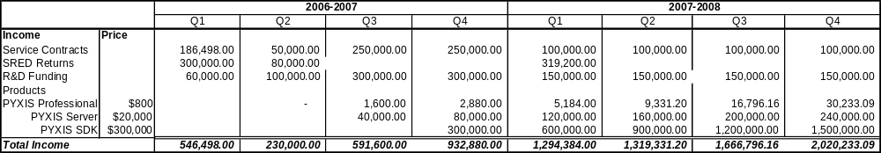

It should be noted that, although PyxNet does provide a revenue stream through licensing, we do not anticipate this revenue stream to begin until year 3.

the PYXIS innovation is currently negotiating Round A ($5-10 Million) Investment. A significant portion of this funding, approximately 20%, will be dedicated to the marketing and sales of PyxNet. Commercialization details can be found in our Business Plan [available upon request]

2.4 Company’s Performance Snapshot –Summary

Please provide information, where applicable, to indicate the incremental impact of this IRAP support on your company’s growth.

Performance Indicators | Current | Expected Incremental Impact of this IRAP Project
No of employees | 14 | 16
Sales (dollar figures) | $1.4M | 20%
Financial Performance (% growth) |  | 20%
# of Products &/or Processes | 1 | 3
Change in Production Capability (% increase) |  | n/a
Technical Capabilities (increased, decreased or same) |  | Increase
Innovation Capability (increased, decreased or same) |  | Increase
# of Linkages (technical and business; increased, decreased or same) |  | Increase
Management Practices (improved or same) |  | Same
New Markets? (Yes/No) |  | Yes
Market Share (% growth) |  | 500%

2.4.1 Previous Support:

the PYXIS innovation has not received any previous IRAP support.

3.0 Project Description

Project Overview

The goal of this project is to implement the PyxNet geo-data distribution channel. PyxNet extends the operation of the PYXIS Digital Earth Reference System to include an entire network of collaborating nodes, by leveraging the bandwidth, storage, and processing capabilities of the entire network. All geo-data, resources, and processes within the network are protected through a distributed license management mechanism which enables their commercialization while maintaining security and privacy.

From a business perspective, the introduction of PyxNet will open our existing products to new markets, and will also enable a new generation of product. The PyxNet-enabled desktop application (based upon the existing PYXIS Digital Earth products) will allow small data publishers to share their geo-coded data, and will allow data consumers access to a broad range of geo-coded data products. The introduction of PyxNet will enable new server applications, including geo-data repositories and analysis servers. Finally, the distributed license management capabilities of PyxNet will create a new product, which is the right to license geo-data and new analysis packages.

PyxNet establishes the framework for the commercialization and productization of the PYXIS innovation’s Digital Earth technology.
Project Benefit

The work undertaken by the PyxNet project will extend the functionality of our existing product suite to large data publishers and build a community of spatial data users. the PYXIS innovation has gained international respect for our innovative technology. We intend to continue to support new research to extend the limits of our product offerings and enable our firm, and other firms, to capitalize on this opportunity.

Not only will the PYXIS innovation increase its research capacity through this initiative but through collaborative academic efforts we intent to support research at Canadian Universities as well. Primarily, we are building a foundation for a Centre of Excellence at the University of Alberta in cooperation with Dr. Arturo Sanchez of the Centre for Earth Observation Science.

Further, Canada has an opportunity to showcase government supported technology on the world stage. As an example, the IUCN-World Conservation Union has supported the PYXIS Global Grid System as the solution for Conservation Commons (www.conservationcommons.org). Achim Steiner, the Director General of the United Nations Environmental Program (www.unep.org) is aware of, and interested in, our technology. PyxNet is an essential component of our whole product offering to this disparate community requiring ways to manage the sharing of spatial data set.

  - Technical Objectives

- Create a distribution channel for geo-coded data. (pass/fail)
  - Enable point to point communication;
  - Manage and track channel usage;
  - Minimal requirement for central server management. Specifically, a license server should be able to support 1000 active users regardless of activity level (simulated for the purpose of this project.)
- Manage licenses for channel content. (pass/fail)
  - Allow user to publish a geo-located data pack;
  - Associate specific license with each data pack. Ensure that all data pack transmissions carry the specified license;
  - Monitor and administer licensing of each data pack to each individual user;
  - Track and Report on data pack usage.
- Create a grid infrastructure in which individual nodes are permitted to access the resources of the entire grid. Resources include data storage, data processing, and network bandwidth.

  - Technical background

Current Situation

The planet Earth is a dynamic sphere containing interrelationships of environmental systems: an arrangement of geophysical, meteorological and biological activity. Within these natural systems, we create divisions of human-interest, artificial boundaries of geopolitical, functional or demographic areas, and natural boundaries such as watersheds or resource delineations. Human assets or infrastructure, like roads and buildings, serve as detailed areas of interest within human biological habitat.

There is a rapid, and potentially unlimited, growth of global information characterizing these environmental systems as space, airborne and ground-based sensors increase in number and sophistication. There is a corresponding demand for an effective and practical way of handling these diverse and increasingly large, spatial datasets.

There is a substantial market that painfully accepts complicated methods of spatial content integration. Without a solution to this problem, lack of accessibility, profuse duplication, delay and underutilization of spatial data will continue to be the industry norm.

There is a general unmet expectation emerging that all information can be easily accessed and used on-demand through simple net-centric visual data discovery. Space and time are major frameworks that provide humans with a contextual model. These frames should allow disparate digital information to be self organized and accessible. There are some who believe that capability is only possible through a universal spatial reference.

Merging geospatial information of disparate sources, accuracies, precisions, and formats is complex. Unlike textual, non-spatial imagery, and fielded data, spatial temporal data requires a common spatial reference and significant background or meta-data to facilitate cut and paste, overlay and mosaic operations.

A simple platform for visualizing all spatial data will stimulate new functionality and shift cultural expectations toward real-time on-demand location-based data accessibility.

Our Response

The key to the full potential of spatial data can be met only when on-demand integration is possible.
The PYXIS innovation is a unique, powerful, new Earth reference model that presents a simple and inexpensive standard for organizing, combining and transforming spatial data. This is the foundation of our value proposition. The PYXIS innovation is the technology that provides the definitive solution to the complexities of spatial data integration that so many are seeking. Our technology provides an optimized solution for integrating all spatial data into a single medium.
Implementation of our solution will accelerate understanding of the Earth in many ways:
- A High School Earth science class studying plate tectonics;
- Farmer planning to plant soybeans in Iowa;
- A Newspaper Reporter investigating the anatomy of a crime in West Vancouver;
- A Disaster Team responding to an earthquake in Clarington;
- A Public School social studies class learning about westward expansion across North America;
- A Health Organization predicting the migration of HIV infection in the Sudan;
- Environmentalists monitoring changes in the environment due to pipeline construction in Alaska;
- A family organizing their vacation to the Middle East.
A medium in which all geospatial data can be integrated on-demand and enabling multiple spatial applications characterizes the new value network we call Digital Earth. We are following a disruptive path within emerging market segments of Digital Earth. As customers learn to value the preeminence of one Digital Earth, we will begin to disrupt existing technical solutions.

Scientific Basis

Converting an analog source to digital data is done with two steps: sampling, which changes the source to a series of discrete values (called samples or cells), and quantization, which converts each sample to a number. Considerable value is generally experienced within the domain of digitally encoding information when analog values are partitioned into discrete pieces of information – digital sound, high definition TV, etc. The core of such methods is a standard for partitioning and indexing, providing fast access and efficient storage to each discrete value (i.e. each cell).
It has been acknowledged [Please refer to Appendix B: Annotated Bibliography] within the geomatics community that such an approach to Earth reference would enable a new era in geo-informatics: a “Digital” Earth. Such a reference model provides a mechanism to conflate data to a standard which is independent of the data itself. This key capability is the core to the on-demand mapping of disparate spatial content that scientists, field practitioners, and decision-makers seek. Key elements of such a system would be:
- Compact discrete reference to any point on the earth – a tiling of regular equal area cells, at multiple resolutions;
- An efficient indexing that provides both data and coordinate addressing in the most compact representation;
- A precise integer based mathematical systems on top of the spatial indexing.
The PYXIS innovation is a closely packed, uniformly adjacent, multiple resolution, overlapping spatial data ordering model representing the most compact and efficient means of partitioning a surface. PYXIS “space” is defined by a discrete non floating point system reflecting computational optimization and physical realities. When applied to the Earth’s surface, the PYXIS innovation represents an approach that provides a fixed digital partitioning and indexing of the Earth’s surface, essentially a discrete global grid. In short, this approach provides a platform for easy and rapid data integration and visualization. The results are fast access to data representing any location and any level of granularity on the Earth; a digital Earth that unifies vector, raster and matrix data structures on-demand.
The PYXIS global grid (Fig. 2) has advantages over the use of current analog Earth references while still preserving data between it and conventional coordinates:
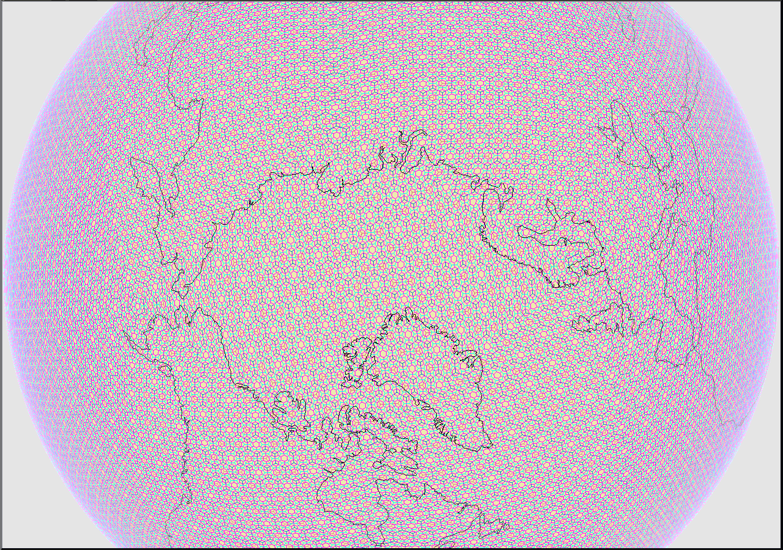
FIGURE 2 – PYXIS Discrete Global Grid
- Encodes spatial location and area of influence within a single unique index value;
- Explicit representation of precision gives better control over location error;
- No “round-off” error on non floating point spatial indexes;
- Unifies Raster and Vector Imagery (in scientific terms translates this from a data format problem to the data structure problem of full and sparse matrices);
- Calculations using PYXIS non floating spatial indexes are significantly faster;
- No requirements for data pre-processing (R-Trees) or data warehousing;
- Consistent equal area location representation across the entire globe;
- Much more compact than floating point geographic coordinates for efficient storage and transmission.
This PYXIS Digital Earth Reference Model (PYXIS DERM) research was completed in March 2005. This model is comprised of a Discrete Global Grid and an Index System that, together, allow all spatial data, everywhere, to be integrated on-demand by any user; this model is the foundation for all product offered by the PYXIS innovation. A full compliment of investigation papers is included in the accompanying CD: Appendix A.

The PYXIS Discrete Global Grid System is a visualization tool that forms the interface between the user and the PYXIS DERM. This product allows the user to find, integrate, and analyze spatial data on-demand. The BETA release of this application has been included in Appendix A.

Current research includes investigations into a PYXIS Image Processing Engine (PIPE) that will extend analysis functionality on a gridded data model and PYXIS Wavelet that will allow efficient transmission of geo-data (traditionally requiring significant bandwidth that is a barrier to usage).
All prior art has been referenced in papers and patent applications.

PyxNet extends our current functionality to a networked environment. A Spatial Network is a completely new product offering and essential to our long term success.

3.3 Plan of Work
Tasks
The attached Gantt chart describes the entire PyxNet project. Some portions of the project are directly fundable by IRAP, while others represent non-fundable effort, including documentation and marketing. The column titled “IRAP Percentage” identifies the fundable portion of each line item.

In this section, we describe the specific items that are IRAP fundable. The italicized text descriptions have been extracted from the full project file.
- Communications Primitives
Describe the model under which network communications will operate. This may include point to point, broadcast, multicast, and/or streaming. Evaluate the need for a central server, and other network management requirements for PyxNet.
  - Define Communications Model
  - Evaluate alternative protocols
  - Integrate protocol
- Distributed License Management
  - Investigate Digital License Management
Investigate and explore the problem of DLM. Identify the requirements of DLM in terms of security, reliability, and efficiency.
The deliverable of this task is a document describing the high level design of the DLM system.
  - Obtain PKI Library
Define and describe PyxNet's needs in terms of encryption. Evaluate various open source and proprietary key-based encryption libraries.
  - DLM - Detailed review, implementation
Evaluate and validate each operation of the DLM System, as defined above.
      - Publication
      - Metadata Access
      - License Request
      - Data Request
      - License Validation (Quick)
  - License Server (Pyxis Commons)
    - Interface Design
This task involves specification and documentation on the interface that the license server exposes to PyxNet clients.
    - Simple License Database
Conceptual design (and implementation) of a database to support license tracking.
    - Server Design
- Raster Data Streaming
After a DataRequest is made using a valid license token, a data transfer will take place. This collection of tasks deals with the transfer of raster data.
  - Define Protocol(s)
Design and describe a raster streaming protocol. The transfer protocol must be extensible, using plug-in codecs to build and interpret the data streams. This will support future extensions, such as compression.
  - Implement Protocol Server
Review and validate the transfer protocol by implementing an encoder.
  - Implement Protocol Client
Review and validate the transfer protocol by implementing a decoder.
  - Compression Technology
    - Generic Compression algorithms
There are a large number of compression algorithms that could be applied to raster data streams. This task includes the selection of one or more appropriate compression algorithms (and the corresponding decompression algorithm) to enable compressed raster streaming, and implementation of one such algorithm.
    - Pyxis Specific compression
There are a number of opportunities for a PYXIS-specific compression algorithm, to take advantage of the concept of "locality" within the PYXIS geometry. This task involves an investigation of the possible algorithms, and the design (and prototype implementation) of one or more algorithms.
- Vector Data Streaming
  - Define Protocol(s)
As vector data is substantially different from raster, we will need to define a suitable protocol for streaming. This protocol will ideally:
- use Pyxis coordinate system for control point mappings
- consider the differences of resolution (it is likely that we will want to stream different content at different resolutions)
- consider clipping vectors to a given geometry
  - Define Aggregation Algorithms
A fundamental concept for vector streaming is to reduce the content of a dataset through aggregation. Thus, a road defined with 1000 closely packed control points might be generalized to 5 control points when represented at a lower resolution. Other features may be joined together, or removed completely as the resolution decreases. This task is to propose (define) algorithms to perform vector data aggregation.
  - Implement Simple Aggregation Algorithms
  - Implement Protocol Server
  - Implement Protocol Client
- Distributed Task Management
  - Task Definition Scheme
Describe and define the concept of "distributed tasks". Define inputs, outputs, and interactions with such tasks.Define a mechanism for describing such tasks, distributing them across nodes, collecting the results, etc.
  - Estimate Calculation
Using active profiling, measure the cost of tasks. Use this data to provide estimates of future tasks (in terms of time, CPU cycles, bandwidth). Some support must be given to prioritize requests.
  - Resource Tracking
Resources consumed during task execution must be tracked. There may be a need to report on usage, and to summarize usage by each client.
  - Bidding/Sourcing
A given task is proposed by a node, and other nodes are asked for estimates. The estimates are evaluated and responsibility for the task is given to one of the bidders (which might be local.) This may also allow a task to be broken into sub-tasks which are shared across several nodes.
- Distributed Geo-Query
A "Geo-Query" is a query against one or more datasets that may include:
- Metadata content (ds name, date, location, resolution, flags, other arbitrary fields...)
- Geography (within a given area, outside, touching, etc)
- Data content (elevation < 0 m)
The result of such a query is essentially a new dataset. The dataset may have features, or be raster.
Distribution of such a query involves spreading the query across several nodes, and gathering their results together to the client. This may follow a broadcast or a tree (or other potential arrangements). In a broadcast scheme, the query is sent to a (large) number of nodes, and all of their results are sent back. In a tree scheme, the client node sends its request out to a small number of nodes, each of which send the request on to other nodes, and gather the results of those queries to send back to the requestor. Note that the tree scheme is recursive, and some thought must be applied to avoid endlessly looping or ongoing requests.
  - Query Language Definition
An essential part of geo-query is the "query language" supported. This task involves research into the requirements for the query protocol, and how those requirements can be met in an extensible manner. This task further requires that we identify a subset of query functionality that supports a meaningful and significant subset of the entire language.
  - Local Metadata Query
Validate the query language by implementing the metadata query on one or more local datasets.
  - Ontological Mappings (Investigation)
Metadata tends to be defined using a number of dialects. In order to meaningfully apply a query to more than one metadata definition, there must be a mechanism for either:
- mapping an abstract query to a specific dialect
- mapping a specific dialect to a generic dialect.
The scope of this task is to identify strategies that can support such ontological mappings, and propose one or more practical experiments to research the problem.
  - Local Data Query
Validate the data query language by implementing data query on one or more local datasets.
  - Distributed Metadata Query
Query for metadata matches across PyxNet, using a distribution strategy (broadcast or tree) and gather results.
  - Distributed Data Query
Query for data matches across PyxNet, using a distribution strategy (broadcast or tree). Gather results.
  - Result aggregation
Results will often overlap
    - in raster datasets, this means two values were found for the same cell
    - in vector datasets, the same feature might be returned multiple times
    - in metadata queries, this might mean that two nodes returned the same dataset.
We need a way to combine such results together. We must take care not to discard data.
- Resource Management
Identify the resources that must be measured/profiled. Identify how each resource can be tracked. Identify a repository for such measurements. Define a protocol that will allow measurements to be shared across nodes of the network.
  - Requirements Planning
  - Quota Persistence
  - Resource Monitoring
- Documentation
  - White Paper (Distributed License Management)
Complete documentation on the technology behind PyxNet. Describe PKI, DLM, swarming, streaming, gridding, and management.
This would serve as the final report to IRAP.
A detailed technical description may be included as an appendix, or under separate cover.
    - Gantt Chart
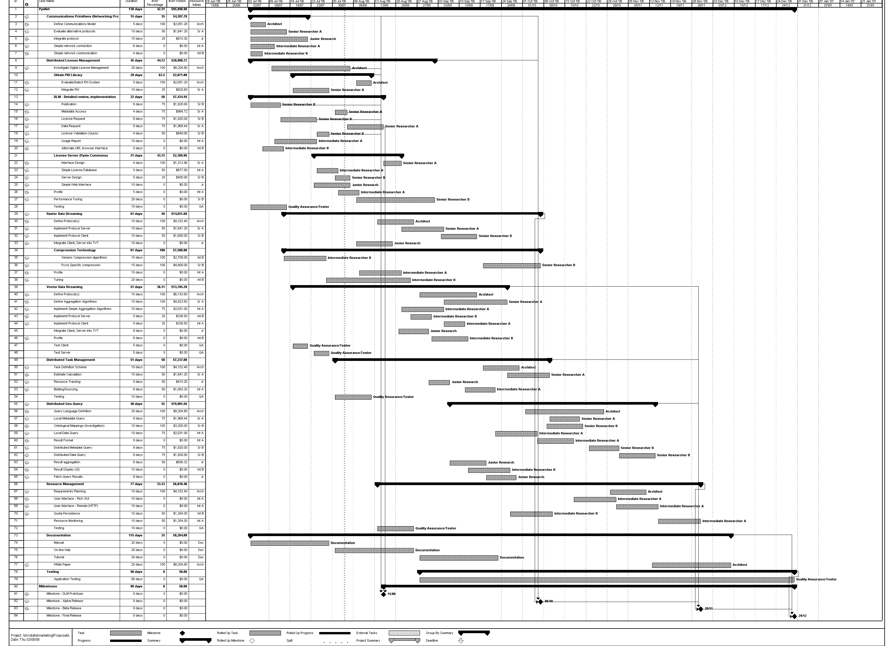
    - Technical Uncertainties/Challenges:

A number of tasks within the project involve a higher degree of uncertainty or risk. The most significant of these include:
- The design of a Distributed License Management Protocol for Geo-Coded data is a significant component in this project, both in terms of its complexity and in terms of its importance. The complexity arises from the balance that must be struck between robustness, reliability, and efficiency in its implementation. The importance of this component is that it transforms PyxNet from a technology into an independent product offering, by permitting the direct licensing of data, analysis, or associated products.
- The design and implementation of Vector Geo-Data Streaming algorithms and protocols is a particularly complex problem. In brief, the reduction of a complex vector-based data set into a smaller, simpler collection of vectors, which reasonably represents the original, is a very hard task.
- The design and implementation of a Distributed Geo-Coded Query Language represents a significant value for our organization. By allowing users to query complex collections of geo-data, we are enabling those users to leverage the value of all of their data. By distributing these queries across PyxNet, that leverage is applied globally.

4.0 Project Team

4.1 Company Employees

Eugene Girard, VP Research, PYXIS holds a BSc(Honours) in Computing and Information Science from Queen’s University, Kingston. He has 14 years experience in the software development industry and has lead our Research Team at PYXIS for the past year.

Dr. Yong Du earned his PhD in Remote Sensing Application from the Southampton University and Ocean University of Qingdao in 1994. Since 1999 he has been working as a scientist with the Canada Centre for Remote Sensing where he has analyzed radiometric properties in image integration, Landsat TM image mosaic, radiometric normalization of multi-temporal TM imagery designed image processing procedures, modelled NDVI seasonal trends using NOAA-AVHRR data, developed algorithms of RADARSAT SAR applications. His primary research areas include targets detection, features extraction, image fusion, wind field estimation, and characterization of hurricane eyes. He has also worked on RADARSAT & ERS SAR image processing, RADARSAT SAR image order & database management and finally, wavelets and multi-fractal applications to remote sensing. As a visiting scientist to the Remote Sensing Group, at the Institute of Ocean Sciences in Sidney, B.C., he developed procedures for retrieval of SST from NOAA-AVHRR, conducted RADARSAT SAR image processing for optimal estimation of wind field and explored NOAA-AVHRR applications to detect red tide and thin cloud. His past research efforts were aimed at: Integration of spatial and temporal satellite data; Haze and thin cloud detection in high resolution satellite image; Targets and features detection in SAR images; Feature tracking in satellite images to reveal ocean currents; RADARSAT SAR and satellite optical image fusion; Wind field estimate in RADARSAT SAR; Characterization of Hurricane in SAR imagery; Retrieval and calibration SST from NOAA-AVHRR. His current research involves texture analysis and feature extraction in RADARSAT SAR imagery with wavelets and multi-fractal analysis for River Ice Monitoring. He is also working on nonlinear image composition to fill gaps in Landsat-ETM SLC-off product. Since joining PYXIS in 2004, he has made significant contribution to PYXIS mathematical models and PYXIS Image Processing Engine. He will act as an advisor to all areas of development with a focused effort on the PIPE components of this proposal. Dr. Du currently works our of our offices in the Innovation Acceleration Centre of the Canadian Centre for Remote Sensing.

Bill Reid, P.Eng., Ryan Taylor, and Chris Howell will all serve as programmers on the project. Their resumes have been included.

4.2 Contractors/Collaborators
Nancy Mucklow from Technically Speaking will be responsible for documentation. Her resume is included as a separate document. Please see her website for qualifications: http://members.kingston.net/nmucklow/

- Project Budget /Schedule

  - Project costs:
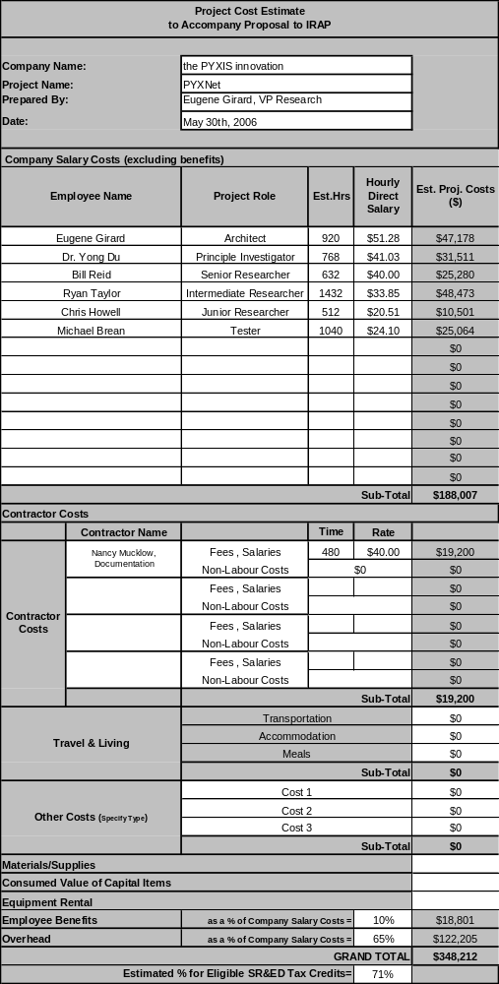

5.2 Estimated Duration:
The PyxNet project will begin on July 3rd, 2006. It is anticipated that the project will continue over a period of 5 months.

6.0 Applications and Market

Market Need
Complicated methods of spatial content integration costs $20B annually.
Still, lack of accessibility, profuse duplication and underutilization of spatial data resources is the norm. Furthermore, there is a new emerging expectation for general on-demand discovery and access to rich and diverse spatial knowledge. Growth in available data is exponential. Connecting disparate spatial data is one of the most significant remaining grand challenges of the information age.

Digital Earth is a medium that can present ubiquitous geo-coded data as coherent, accurate and timely information to the care of one who is posing a question. Evidence based decisions, responsibility and action are a product of knowledgeable choices. Knowledgeable choices are made when one is provided coherent, accurate and timely information. PYXIS technologies are the best reference model for Digital Earth. Such needs and requirements are pervasive through many sectors of the econmomy. PYXIS is focused on emerging tactical evidence based decision needs within Defense and Conservation communities as ideal sectors to introduce our products.

Product Overview
Our geospatial indexing, also known as the PYXIS Digital Earth Reference Model (DERM), forms the basis for PYXIS products and defines our core capability. The PYXIS innovation demonstrates that current methods of Earth reference using an analog model prohibits much sought after requirements for on-the-fly and user driven “pull” model discover and access to spatial data content. Our software is neither a GIS nor an Image Processing application but a powerful new hybrid.

PYXIS Indexing provides a scientifically valid solution for a much sought after capability – on-demand geospatial data integration. PYXIS solves the grand challenge to “spatialize the internet” providing the definitive solution to the search question “Where?”. The PYXIS approach is fully scalable: from bits of a point feature to terabytes of satellite imagery, from whole continents down to a microbe, from mass environmental supercomputing to hand held devices. The method has been designed to compliment and support traditional encoding techniques and spatial applications, not replace them.

Product Offering
PYXIS Discrete Global Grid System - allows ALL spatial content, devices, events and observations anywhere, at any scale, any format to be:
- Accessed and shared - netcentric;
- Integrated on-demand– power to the edge;
- Advanced 3D visualizated, analyzed and modeled;
- Spatially managed– with an organization for each location like nodes by a network IP address.

PYXNet P2P Spatial Data Sharing Network – this application will allow users to publish data using license management environment. It will facilitate rapid transmission of data in a peer-to-peer environment.

PYXIS Spatial Image Server – this enterprise software will facilitate spatial data storage and retrieval, based on location, for distributors of massive amounts of spatial data.

PYXIS Universal Gazetteer - will allow search capabilities on unstructured spatial data by linking location text strings to PYXISIndex.

PYXIS Software Development Kit - allows outside industry or programmers to develop applications on our the PYXIS DERM.

OEM Licenses - allows other solutions providers to resell our products under their branding.

Market Condition
The Digital Earth market is rapidly emerging. Visualization technologies such as Google Earth increase general awareness of spatial imagery; users are beginning to expect satellite imagery as a backdrop to digital mapping. Traditional geospatial industries have identified INTEGRATION as the major barrier for growth and increased functionality. Culturally, users are demanding access to all information with complimentary application that allows them to make evidence based decisions.

- Financial Position
Project Cost Breakdown and Cash Flow (see Appendix C: Project Budget)

Total Project Cost: | 348,212
Breakdown:
Contact Holdback (ISTAR) | 44,502
IRAP | 95,998.98
PYXIS | 207,711

Project Cash Flow
Expenses | July | August | September | October | November | December
Salaries | 34,183.09 | 34,183.09 | 34,183.09 | 34,183.09 | 34,183.09 | 17,091.55
Consultant |  |  |  | 7,680.00 | 7,680.00 | 3,840.00
Benefits | 3,418.31 | 3,418.31 | 3,418.31 | 3,418.31 | 3,418.31 | 1,709.15
Overhead | 22,219.01 | 22,219.01 | 22,219.01 | 22,219.01 | 22,219.01 | 11,109.50
Total: | 59,820.41 | 59,820.41 | 59,820.41 | 67,500.41 | 67,500.41 | 33,750.20
Income
IRAP |  | 20,509.85 | 20,509.85 | 20,509.85 | 20,509.85 | 20,509.85
PYXIS* | 59,820.41 | 39,310.55 | 39,310.55 | 46,990.55 | 46,990.55 | 13,240.35
 | 59,820.41 | 59,820.41 | 59,820.41 | 67,500.41 | 67,500.41 | 33,750.20
[*Projected AR | 47,000.00 | 71,000.00 | 75,000.00 | 575,000.00 | 100,000.00 | 100,000.00 | ]

the PYXIS innovation will use approximately $60k in working capital to manage cash flow. Financial Summaries (Income Statements and Balance Sheets) are included in Appendix A.

- Environment, Ethics
The PYXIS innovation works directly with international organizations including the United Nations Environmental Programme, IUCN – The World Conservation Union to ensure that the software we create is useful for the protection of our earth. The work itself has no negative environmental impact. There are no human or animal ethical issues related to the creation of PyxNet.

- Intellectual Property (IP) Certifications/Ownership

9a Ownership of IP on which this project is based
Canadian Patent Application – 2,436,312 filed August 1 2003 with subsequent filings in US, Australia, Europe and India. PYXIS is actively pursuing an examination of its patent in the USA.

9b Ownership of IP resulting from this project
Developing and protecting our Intellectual Property is key to the success of the PYXIS innovation inc. We are establishing these rights through domestic and international patent filings, trademark and copyrights. We believe the technological and market consequences of PYXIS are significant and therefore, we will engage expert resources to establish and maintain our claims.

- Establish the need for IRAP’s funding support.

In an emerging market, first to market is essential. IRAP Assistance will allow us to continue our leadership position in the Digital Earth market. Without IRAP assistance, research will continue through funding from investment or sales however, critical months may be lost.

Appendix A: Application and Full Papers Provided on CD

Appendix B: Annotated Bibliography

Vince, Andrew, “A Question Concerning Subdivision of the 3-Dimensional Sphere”, Nov 14, 2005. Discusses spatial subdivisions, applied to the 3-Dimensional Sphere, and defines terminology such as barycenter, duals, central subdivision. This report addresses Line Item #7 from the DIR 563 Statement of Work, “Multi Dimensional Aspects”.
Vince, Andrew, “A Conjecture Concerning the Existence of a Group Structure on Discrete Sets of Points on the Sphere”, February 9th, 2006. Discusses Abelian groups, their properties, and briefly concludes that there is no such group that can be defined for the PYXIS DERM. This report addresses Line Item #4 from the DIR 563 Statement of Work, “PYXIS as a number system”.
Girard, Eugene, “Introduction to IRAP”, October 25th, 2005. Discusses the architecture and design of the BitTorrent protocol, its applicability and suitability to PYXIS’ networking needs. This report addresses Line Item #22 from the DIR 563 Statement of Work, “Evaluate Streambase Architectures”.
Girard, Eugene, “Data Characteristics”, November 10th, 2005. Reports on the high level characteristics of data. This report addresses Line Item #20 from the DIR 563 Statement of Work, “Data Characterization”.
Zheng, Xiqiang, Ritter, Gerhard X., Wilson, David C., Vince, Andrew, “Fast Discrete Fourier Transform Algorithms on Regular Hexagonal Structures”, March 2006. In this paper, new structures called regular hexagonal structures are introduced. It is proved that any of those new structures is exactly a period of a quotient lattice. Hence the discrete Fourier transform (DFT) on those structures can be computed efficiently. It is shown that the shape of the support of the frequency domain is similar to that of the spatial domain. Furthermore some fast algorithms to compute the DFT on those structures are shown, and the importance of those structures is addressed. This report addresses Line Item #5 from the DIR 563 Statement of Work, “Fast Fourier Transforms”.
Girard, Eugene, “DIR 563 Overview”, December, 2005. A presentation for internal user groups (development staff, marketing, sales) to describe the scope and goals of the DIR.
Johnson, Colleen, Peterson, Perry, “DIR 563 Statement of Work”, April 11, 2005. The contract on which the DIR is defined. All “Line item” references in this bibliography refer to this document.
Vince, Andrew, “Discrete Lines and Wandering Paths”, November 10, 2005. The problem of finding an approximation to a geometric line by a discrete line using pixels is ubiquitous in computer graphics applications. We show that this discrete line problem in Rn+1, for grids of any shape, is equivalent to a geometry problem in Rn concerning the minimization of the distance a certain type of closed polygonal path wanders from the origin. This geometry problem is solved completely in dimension 1 (corresponding to 2-dimensional grids), and two simple and efficient algorithms provide near optimum solutions in higher dimensions.
Lepage, Marc A., “Discrete Global Tesseral Arithmetic Part One: Foundations”, January 17, 2006. Explores tesseral arithmetic on the truncated icosahedron, and suggests several approaches to indexing its faces. This report addresses Line Item #4 from the DIR 563 Statement of Work, “PYXIS as a number system”.
Girard, Eugene, “Encoding PYXIS Indexes”, August 4th, 2005. Discusses the binary representation of the PYXIS index, using variable length and fixed-length encoding schemes. This report addresses Line Item #21 from the DIR 563 Statement of Work, “Data Pipeline and Encoder/Decoder (CoDecs)”.
Girard, Eugene, “Calculating Cell Counts at an Arbitrary Resolution”, August 25, 2005. Defines a formula for calculating the number of cells at a given PYXIS resolution. This report addresses Line Item #1 from the DIR 563 Statement of Work, “Sampling”.
Girard, Eugene, “Largest Rectangle in a PYXIS Cell”, September 29, 2005. Defines an algorithm for determining the largest continuous rectangle that can be placed in a PYXIS tile of a given resolution, along with the resulting data. This report addresses Line Item #1 from the DIR 563 Statement of Work, “Sampling”.
Girard, Eugene, “PYXIS Image Processing Engine Requirements Specification”, September 29, 2005. Defines the software requirements for the PIPE development platform. This report addresses Line Items #8-12 from the DIR 563 Statement of Work.
Zheng, Xiqiang et al, “Some Experimental Results of DFT and Some Simple Sampling Schemes”. Discussion paper on DFT and sampling algorithms applied to conventional imagery. This report addresses Line Item #5 from the DIR 563 Statement of Work, “Fast Fourier Transforms”. This report also addresses Line Item #1 from the DIR 563 Statement of Work, “Sampling”.
Du, Yong, “On the Relation and Conversion between Pyxis Innovation and Other Systems”. Compares and contrasts rectangular grids, the PYXIS DERM grid, and GBT. Discusses and illustrates sampling algorithms for converting rectangular data into PYXIS DERM gridded data. This report addresses Line Item #1 from the DIR 563 Statement of Work, “Sampling”.
Du, Yong, “Optimal resampling to preserve the original information in the conversion of square grid image to Pyxis DDGG”, Defines the function that calculates the PYXIS resolution that will optimally sample a given square grid. This report addresses Line Item #1 from the DIR 563 Statement of Work, “Sampling”.
Zheng, Xiqiang et al, “Fast Algorithms For the Discrete Fourier Transform on Regular Hexagonal Structres”. Defines hexagonal DFT on ORH(n). Most of the content was incorporated into “Fast Discrete Fourier Transform Algorithms on Regular Hexagonal Structures”. This report addresses Line Item #5 from the DIR 563 Statement of Work, “Fast Fourier Transforms”.
Zheng, Xiqiang et al, “Some Comments on the Periodic Extension in Eric’s Paper”. Detailed examination of a paper by E Anterrieu et al, “Apodization Functions for 2-D Hexagonally Sampled Synthetic Aperture Imaging Radiometers”. The subject paper uses a prototile that cannot tile the plane. This report addresses Line Item #5 from the DIR 563 Statement of Work, “Fast Fourier Transforms”.
Vince, Andrew, “A Question Concerning Resampling”. Discusses the geometry of hexagons versus squares. This report addresses Line Item #1 from the DIR 563 Statement of Work, “Sampling”.
Yarrow, Shawn, “SAR Image Investigation”, September 28, 2005. Describes the current implementation of visualization of SAR imagery, within the PYXTVT application. This report addresses Line Item #20 from the DIR 563 Statement of Work, “Data Characterization”.
Vince, Andrew, “Transformations of Images”. Discusses the possible transformations on the sphere and on the plane. This report addresses Line Item #13 from the DIR 563 Statement of Work, “Transformation Equations”.
Vince, Andrew, “Transformations of the Pyxis Plane using Pyxis Coordinates”. Discusses the possible transformations that will map cells to other cells. This report addresses Line Item #13 from the DIR 563 Statement of Work, “Transformation Equations”.
Vince, Andrew, “Comments on Minimal Sampling Resolution”, February 16, 2006. Discusses the mathematical relationship between sampling frequency and output quality. This report addresses Line Item #1 from the DIR 563 Statement of Work, “Sampling”.
Vince, Andrew, “Straightest Geodesics”, February 23, 2006. Review of the paper “Straightest Geodesics on Polyhedral Surfaces”, by Polthier and Schmies. Concludes that the algorithm does not necessarily correspond to “Great Arc Circles” that are necessary in PYXIS.
Du, Yong, “Quantitative Estimation of Re-samplings in the Conversion between Radarsat Data and Pyxis Grid”, February 14, 2006. Proposes an algorithm for comparing different resamplings, using DFT/FFT/Wavelet transformations. This report addresses Line Item #1 from the DIR 563 Statement of Work, “Sampling”.
Du, Yong, “Experiment of Multi-Scale Decomposition of Pyxis - Part One”, April 7, 2006. Defines an algorithm for image segmentation constructed from simple filter operations, including the Zoom-In, Zoom-Out, Image Subtraction. The algorithm approximates the effects of high frequency and low frequency filters, and is intended to emulate the operation of a wavelet. This report addresses Line Item #16 from the DIR 563 Statement of Work, “Image Segmentation”.
Zheng, Xiqiang, “A note about the significance of Hexagonal DFT Research”, April 24, 2006. Discusses the novelty and significance of the UofF research. Identifies that their hexagonal DFT is more accurate than alternative algorithms, and is quite fast.
Vince, Andrew, “PYXIS DERM - A Technical Overview”, April 6, 2006. Defines the PYXIS DERM, the associated projections, gridding, and indexing.
Vince, Andrew, “Transition Between PYXIS Tiles”, May 2, 2006. Discusses the complications arising from transitions (movement) between tiles on different faces of the truncated icosahedron. Proposes two approaches to the issue: tile extension, and grid transformation.

Appendix C: Resumes Provided in a Separate Document

Appendix A: Financial Summaries Provided in a Separate Document

Canadian Patent filed by the PYXIS innovation on August 1st, 2003. Subsequent Patents filed in US, Europe, India, and Australia.
Please note that we have revised this description to accurately reflect the uncertainties in this task and the degree of importance as foundation work.

